**WIF3007 Design Pattern Mid Semester Test Correction**

1. A) Observer Design Pattern

B) It is behavioural category and object scope

C) If Sport Mania want to make changes to their package it will not require changes from the

subscriber. Hence, observer is not affected by subject and vice versa

D) UML Diagram

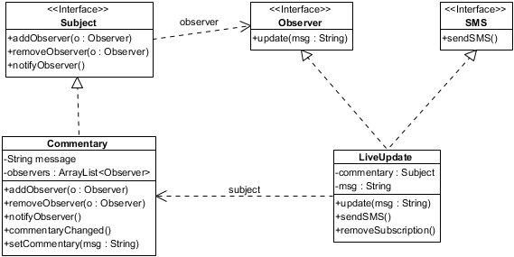

E) Refer to source code attached together in the zip file

1. A) Adapter Design Pattern

B) UML Diagram

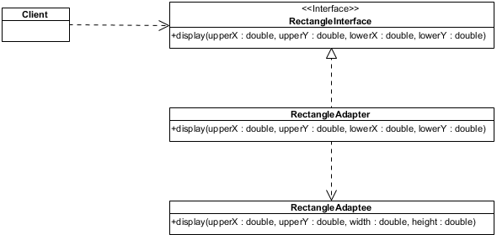

C) It is structural category and object scope